**MEMO Gr. 10 March Assessment**

**QUESTION 1**

1.1 Show that the decimal  is a rational number. (4)

$Set 10x=32,181818…$ √ $Then 1000x=3218,181818…$ $1000x-10x=3218,181818…-32,181818…$ √ $990x=3186$ √ $x=\frac{3186}{990}$ √

1.2 Determine, without the use of a calculator, between which two integers

the number  will lie. (2)

**[6]**

$\sqrt{25}<\sqrt{30}<\sqrt{36}$ √ $5<\sqrt{30}<6$ √

**QUESTION 2**

Expand and simplify:

2.1  (3)

 √ trinomial; √ FOIL; √ answer

2.2  (2)

 √ diff squares; √ answer

2.3  (2)

 √ 1st term; √ second term

2.4  (3)

 √ first (); √ second (); √ answer

**[10]**

**QUESTION 3**

Factorise the following expressions completely:

3.1  (3)

$=\left(a-b\right)\left(a-b\right)-\left(-3\right)\left(a-b\right)$ √ sign change $=(a-b)(a-b+3)$ √√ each bracket

3.2  (3)

 √ first (); √ second bracket squared; √ signs

3.3  (4)

 √ grouping

√ (m-1); √ (m-n); √ (m+1)

**[10]**

**QUESTION 4**

Simplify the following expressions, assuming all denominators are non-zero:

4.1  (7)

$=\frac{\left(2x-1\right)\left(2x+1\right)}{\left(3x+1\right)\left(x+3\right)}÷\frac{\left(3x+1\right)\left(2x+1\right)}{\left(x+3\right)\left(4x-1\right)}×\frac{\left(3x+1\right)\left(3x+1\right)}{\left(4x-1\right)\left(2x-1\right)}$ √ per factorization done (1x6=6) $=\frac{\left(2x-1\right)\left(2x+1\right)}{\left(3x+1\right)\left(x+3\right)}×\frac{\left(x+3\right)\left(4x-1\right)}{\left(3x+1\right)\left(2x+1\right)}×\frac{\left(3x+1\right)\left(3x+1\right)}{\left(4x-1\right)\left(2x-1\right)}$ $=1$ √ answer

4.2  (7)

√ factorize cubes; √ factorise trinomial;

√ common denominator; √√√ multiplied correct in numerator; √ answer in numerator

**[14]**

**QUESTION 5**

5.1 Given that  and prove that  and  (5)

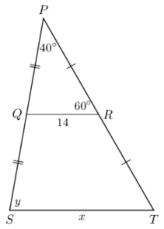

See attached answer.

5.2 In the diagram, **AODE** is a parallelogram. Also, **OF** is parallel to **BA**.

**Prove that ABOE is a parallelogram.** (5)

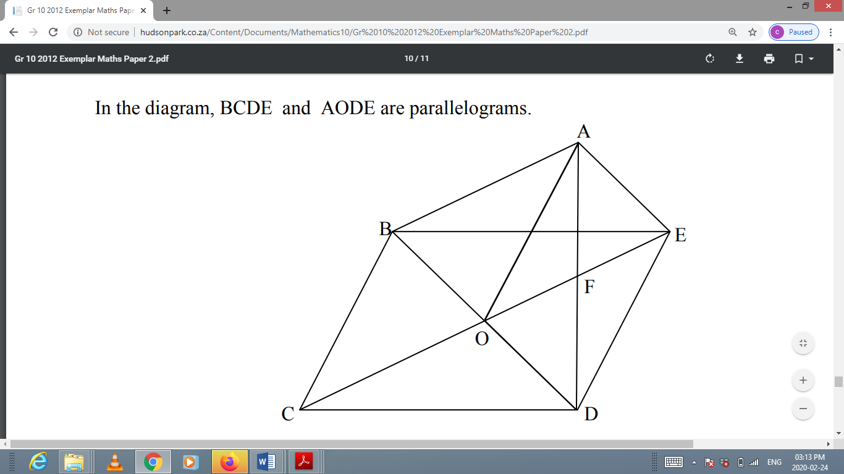

|  |  |
| --- | --- |
| **STATEMENT** | **REASON** |
| 1)  **√ S** | Given; **√ R** |
| Thus |  |
| 2)  **√ S** | Opp sides of parm AODE is parallel; **√ R** |
| Thus | OD extended to DB |
|  |  |
| ABOE is a parallellogram | 2 pairs of opposite sides are parallel |
|  | **√ R** |

**Total: /50**